Name:TH Kalpakam

Roll no:AM.EN.U4ECE22048

19ECE311-COMPUTER NETWORKS

**ASSIGNMENT-2**

**Create all the topologies discussed in class in Cisco Packet Tracer (CPT).**

**BUS TOPOLOGY**

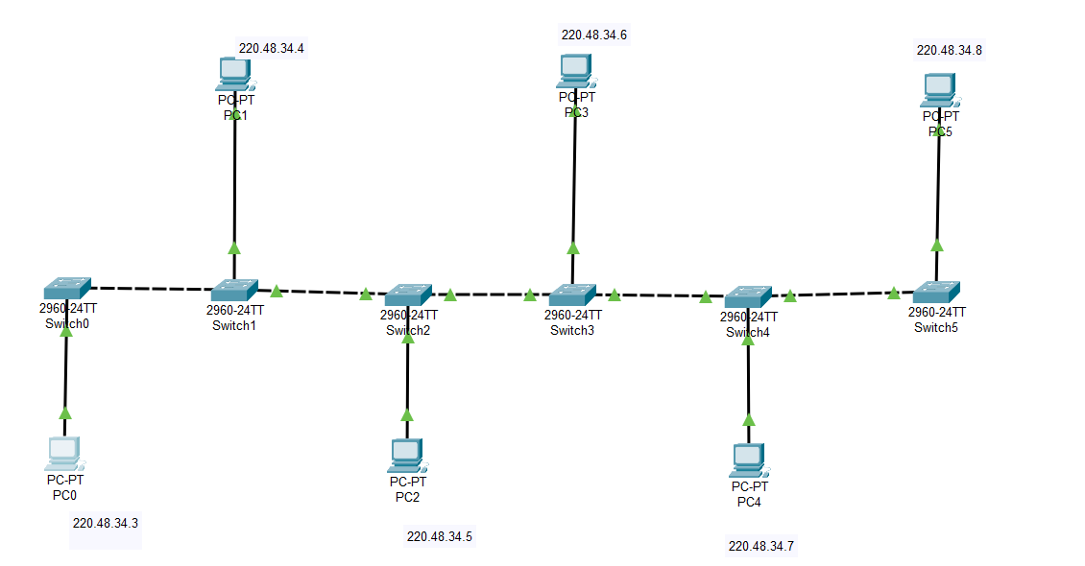

**RING TOPOLOGY**

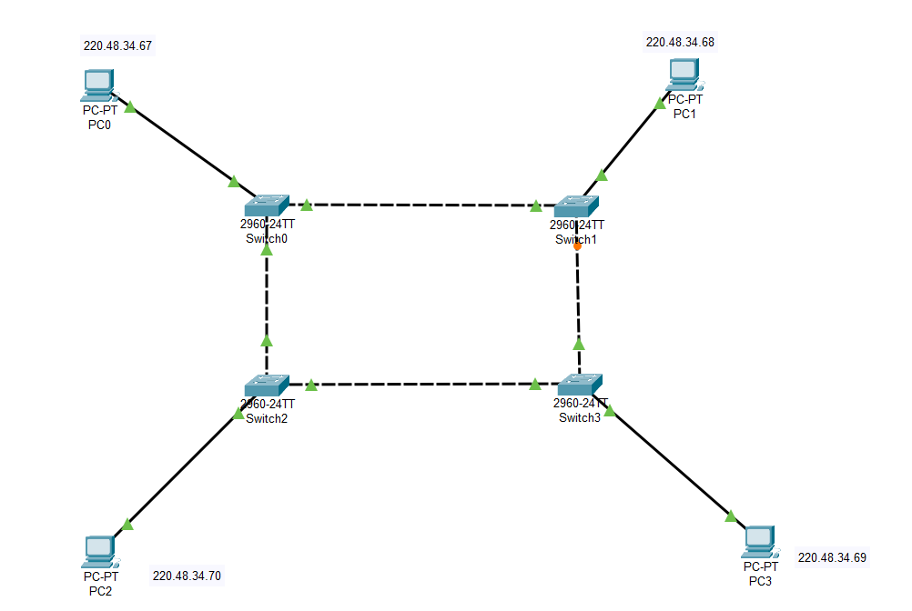

**STAR TOPOLOGY**

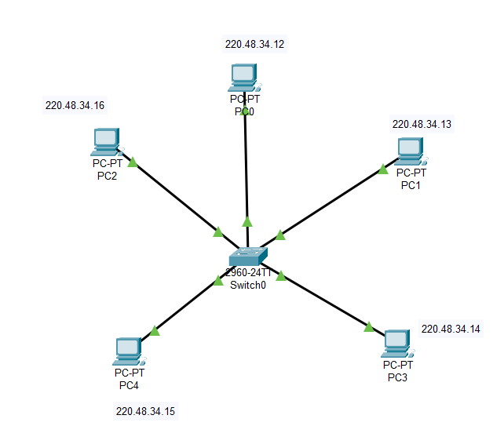

**TREE TOPOLOGY**

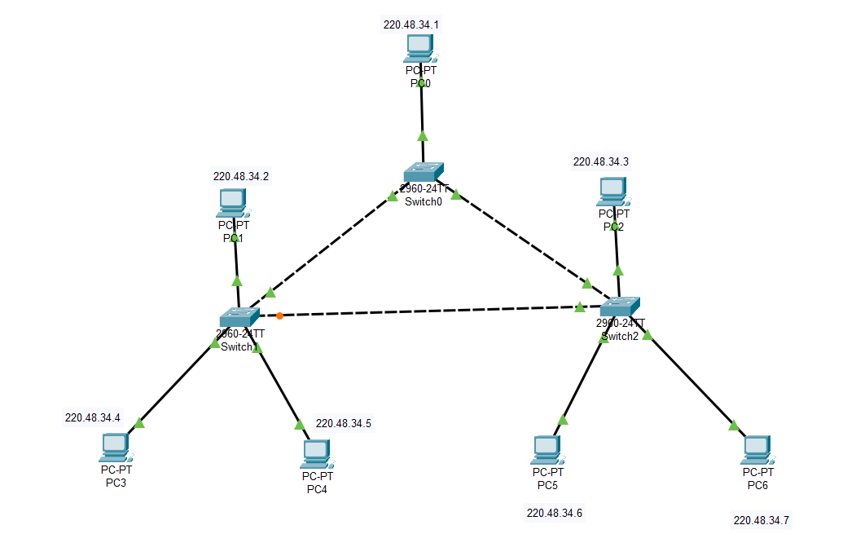

**MESH TOPOLOGY**

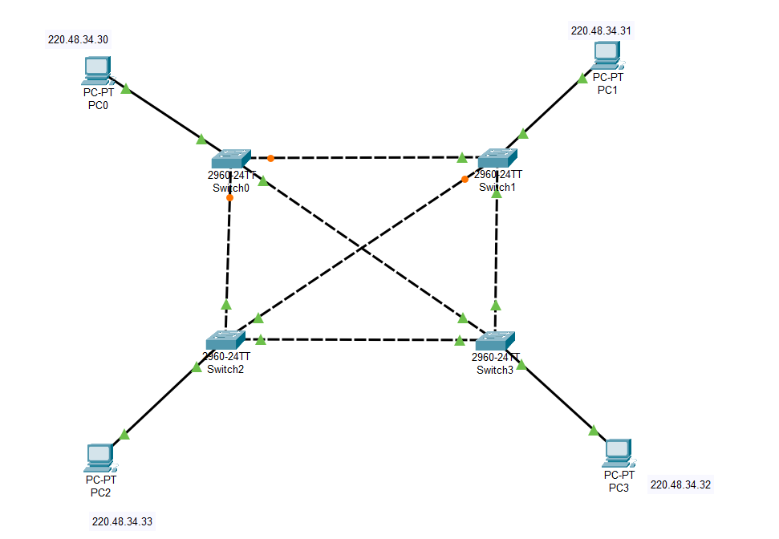

**HYBRID TOPOLOGY**

